Jmol tutorials

**Benzene. (all models ball and stick. I have drawn them as skeletal in some of my figures used to illustrate but that was just for quickness)**

State 1: Aromatic hydrocarbons are cyclic hydrocarbons where the carbon atoms are joined by sigma bonds and electrons in pi bonds that are delocalized over the entire molecule. Benzene, with the chemical formula C6H6, is the simplest aromatic hydrocarbon.

Ball and stick model of benzene with no double bonds or delocalization shown.

State 2: The six carbon atoms form a six-membered ring structure, with the H atoms oriented outward. All of the atoms of benzene are coplanar.

Ball and stick model of benzene from above with no double bonds or delocalization shown, rotate so looking down the plane of the molecule to visualize all atoms in the same plane

State 3: Each carbon atom in benzene has four valence electrons to contribute to chemical bond formation. In order to draw a proper Lewis structure for benzene, an alternating sequence of double bonds must be drawn within the ring system so that all valence electrons are accounted for and each C atom satisfies the octet rule. Shown here is the ball and stick rendering of the Lewis structure where the double bonds are between the indicated C atoms. To keep track of where the double bonds are shown, the C atoms have been numbered from 1 to 6 starting at upper left and moving clockwise. In this structure, the double bonds are shown between C1 and C2, C3 and C4, and C5 and C6.

Ball and stick model of benzene where actual double bonds are shown. Place numbers 1-6 on C atoms, db are between C1 and C2, C3 and C4, and C5 and C6.

State 4. The double bonds could also have been drawn between C2 and C3, C4 and C5, and C6 and C1 when drawing the Lewis structure of benzene, as shown here.

Ball and stick model of benzene where actual double bonds are shown. keep numbers 1-6 on C atoms, and switch db to being between C2 and C3, C4 and C5, and C6and C1.

State 5: Neither of the structures shown in states 3 and 4 are correct for describing the bonding used by the electrons in the pi orbitals on the carbon atoms of benzene. Instead, benzene exhibits **resonance**, where the electrons in the p orbitals giving rise to the pi bonds are delocalized over the entire molecule. In this view, the electrons in the p orbitals are shown as being delocalized by using dashed lines between each C-C bond position. This rendition highlights the fact that there are not true single and double bonds in benzene, but instead, each C-C bond is a composite of a single bond and partial double bond, such that the bond order is 1.5.

Ball and stick model of benzene where dashed lines are shown for partial double bonds.

State 6: We will now examine the molecular geometry of benzene and the hybrid orbitals used for bonding.

Rotate so looking at plane perpendicular to screenState 7: Using either Lewis structure shown in states 3 and 4, it is apparent that there are three electron domains surrounding each C atom of benzene. There are no lone pairs on the C atoms, so the electron domain and molecular geometries are the same (each C atom is AX3E0). The molecular geometry of each carbon atom is therefore trigonal planar. This is highlighted here for one of the carbon atoms in benzene.

Show lewis structure from state 3. Highlight trigonal planar unit around C1

State 8: Since each C atom has a trigonal planar molecular geometry, all of the atoms in benzene are coplanar.

Structure with double bond shown as delocalized, rotate it to looking down plane of all atoms

State 9: All of the bond angles in benzene are exactly 120 degrees.

Add bond angles to C1 and zoom in on it to see them. 120 is correct for all the angles in benzene

State 10: Each carbon atom is sp2-hybridized and forms sigma bonds with the two C atoms and single H atom to which it is bonded. The single electron in the atomic orbital of each H atom is used for chemical bond formation.

Zoom into C1 and show sigma bonds to C2, C6, and H

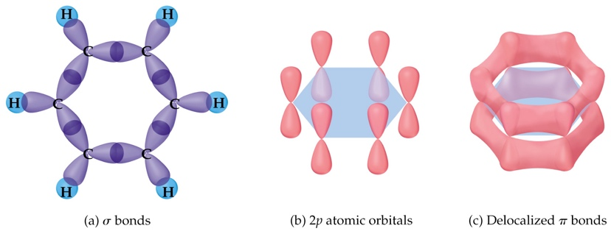State 11: All of the sigma bonds in benzene are shown here.

All sigma bonds shown.

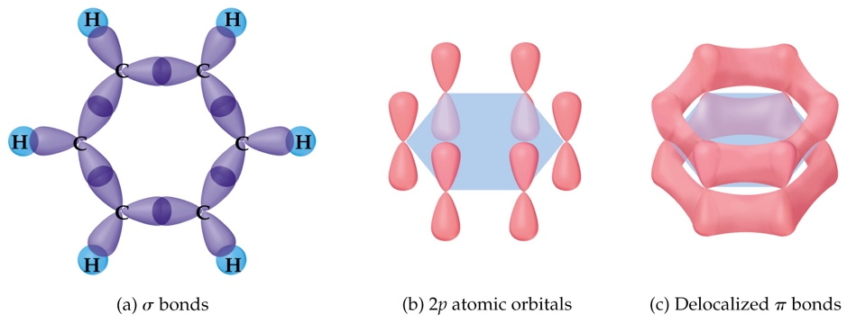State 12: Each C atom has an unhybridized p orbital containing a single electron. The p orbitals have lobes of electron density above and below the plane of the benzene ring.

Show p orbitals on each C atom

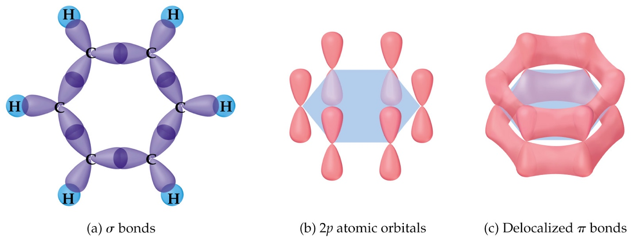State 13: As discussed above, there are no true double bonds in benzene. Instead, the electron density from the six electrons in the p orbitals is delocalized over the entire molecule. Note how there are continuous (unbroken) circles or rings of electron density in the benzene ring lying above and below the plane of the molecule. Such continuous circles, or rings, of delocalized electron density are hallmarks of aromatic compounds.

Show delocalized ring systems formed from p orbitals